**NUEVA VIZCAYA STATE UNIVERSITY**



Bambang, Nueva Vizcaya 3702

**COLLEGE OF INDUSTRIAL TECHNOLOGY**

Information Technology Department

**CASA ALL'INTERNO LA SCUOLA: Dormitory Online Reservation and Monitoring System**

**Nueva Vizcaya State University**

**Bambang Campus**

**Dan Vincent Angelo L. Necosia**

**Beth A. Matis**

**Beverly C. Orencia**

**Table of Content**

|  |  |
| --- | --- |
|  | Page |
| Title Page |  |
| APPROVAL SHEET |  |
| ACKNOWLEDGEMENT |  |
| ABSTRACT |  |
| CONTENTS |  |
| LIST OF TABLES |  |
| LIST OF FIGURES |  |

|  |  |  |
| --- | --- | --- |
|  |  | Page |
| **CHAPTER I** | Introduction  Project Context  Purpose and Description  Objectives of the Project  Scope and Limitations  Conceptual Framework  Definition of Terms |  |
| **CHAPTER II** | RRLS for Each Objective  Thematic Based on Keywords from Title  Technical Background |  |
| **CHAPTER III** | Development Methodology  Requirements Analysis  Requirements Documentation  Design of Systems  Development and Testing  Description of the Prototype  Implementation Plan |  |

Chapter I

**The Problem and Its Background**

**INTRODUCTION**

The existence of computers has had a significant impact on every aspect of human life in today's modern civilization. Our society has benefited greatly from the computerization of practically all jobs because it allows for the quick completion of all tasks that require information. The advancement of one's life has been greatly aided by computer technology. The majority of businesses, corporations, and institutions evolved their usage of such technology to aid themselves in working more effectively with less time and effort, improving productivity, profit, and customer satisfaction. The development of a computer system is one instance of computer technology.

It is not a secret that the current trend today is internet browsing, which has grown and classified as necessity for daily living. There are many organizations that uses internet as the backbone of their every transaction.

One of the top universities in the nation is Nueva Vizcaya State University. Students can get educational services from the university, and residents of Nueva Vizcaya can enroll in extension programs. The university serves as a research center for a variety of academic disciplines. Numerous managerial tasks are carried out within the university. One of the key management tasks is the allocation and arrangement of student housing, which is done as part of the management operations at Nueva Vizcaya State University. There could be a difficulty with the management of the dorms in this process. In order to discover, assess, and perhaps address those issues, the team started this project.

We, researchers have proposed the study “CASA ALL'INTERNO LA SCUOLA: Dormitory Online Reservation and Monitoring System” that will make the application for reservation more easily, accurate, and faster. The study also removes the “paper-based system” and replaces it with a computerized system. It can also help both dormitory manager and students to make ease of every transaction possible.

**Project Context**

The state institution known as Nueva Vizcaya State University was founded in 1997. One of the most reputable colleges in the region. Since it first began to run

Ones the new system is implemented, firstly proctors and proctor managers are benefited from the system in such a way that the quality and performance of their work is improved, the time they spent for manual operation is significantly reduced and their management and control of their job is improved. Secondly students are not expected to be in campus to know about their dormitory information. That is, once the allocation report is generated by the system, the system provides an interface which enables the students to know about their dormitory information, about academic colander and some academic announcements and finally they submit their personal information through the Internet

The project context of any proposal not only gives an introduction to your project but it also builds up a justification process to help the donor agency convince as to why it is important to start this project and how can your organization resolve the ‘problem in question’ by implementing the proposed activities. In this sample proposal, you will see that the context and justification process has been broken up into 3 parts: ‘The Challenges’, ‘The Opportunity’ and ‘Why Now?’ It is a wonderful way of drawing attention of the reader and also give enough reasons as to why you require this funding to implement the project.

**Purpose and Description**

This project is initiated to develop system, as a final year project for completing a study of B.S. Degree in Computer Science and IT. The team is organized to develop a web-based Dormitory Online Reservation and Management System which will enable the project team to complete their requirements in Capstone II.

**Objectives of the Project**

The main objective of this project is to develop a Online Reservation and Management System for NVSU Bambang Campus which give the students the convenience to pass an application to the NVSU Dormitory manager. This is achieved by designing a web-based application program that will change the actual manual processing to a computerized environment.

**Scope of the project**

Designing and Implementing the Database, Designing and Implementing Graphical User interface including forms and reports.

**Limitation Of the project**

This project is limited only to those activities and operations related to the dormitory management which the team is intended to deal with. The project is limited to developing the web-based dormitory management system.

**Conceptual Framework**

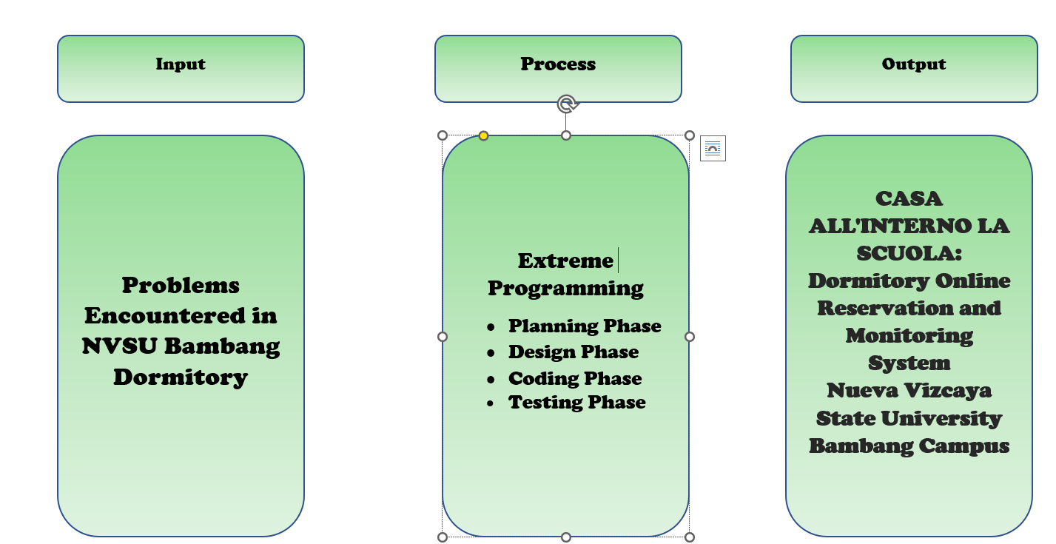

**Definition of Terms**

**MVC**- also known as Model-View-Controller is nothing more than the integration of three components: Model, View, and Controller. The Model component of the MVC, as its name suggests, contains the application data that is required, the View component is used to display data and control actions, and the Controller component serves as the link between the Model and View components. It is a well-known alternative for systems with numerous views of large amounts of data to quickly change it.

**Web Application** – A web application is a computer software that executes a certain task using a web browser. Web apps

**Tenants** - are individuals with the right to use and occupy a rental property under a rental agreement or lease

Chapter II

**Review of Related Literature and Systems**

Each institution has a unique system that enables quick and efficient information processing. The student dormitory management has always been a crucial component of school management work, and it should be enhanced and made better as the size of students has progressively grown. As a result, the amount of student information is becoming increasingly large. This is undoubtedly for the schools with large student information storage to offer a practical and effective mode of operation, so that individuals from the heavy data processing and maintenance out of relief, replaced by a friendly interface, the design of a very user-friendly front Application, the user will feel very easy to operate (Jingxiu, 2017).

The administration procedure is still carried out manually at our university’s dormitory using paper-based applications that students must print, fill out, and submit to the residence offices. It presents a challenging situation because the registration procedure, in some ways, takes longer to complete from beginning to end. Students from remote locations who can't get to the dormitory will struggle to find a suitable place to stay where the reapplication procedure might take place.

To have an effective online reservation and management system, the development of the CASA ALL'INTERNO LA SCUOLA should support the student's online admission, payment, and booking process as well as the staff's ability to control and manage integrated programs or activities in accordance with a predetermined schedule.

Every organization needs to have a defined strategy in information management process flow, which involves data processing, data storage, data monitoring and utilization. It must be clear that procedure is a cycle that displays the relationship between each of the steps in the process (Pastor, 2020).

The research application's goal is to promote a web-based residential framework for enhancing software quality and reliability, which is beneficial for applications developed in an association. This study can be used to track student difficulties, allocate quarters to people, and reduce student complaints about a certain program or module (Mothe, KK. Soraguni, R. Vakity, 2015).

Currently, most schools have strict work attendance policies, dormitory checks at district division signal language of danger, and other measures to support students. However, these measures bring a great deal of work pressure to school administrators whose efficiency isn't yet high and who must leave a lot of manpower and financial resources unfilled. Additionally, even though teachers and parents are both the primary caregivers for their kids, and that running a household is a job that is challenging to coordinate with school, none of them have any kind of efficient method or tool for connecting work and life (Renqiu Vocational and Technical Education Center, 2013).

**Technical Background**

**Laravel**

Laravel is a free and open-source PHP web framework,[2] created by Taylor Otwell and intended for the development of web applications following the model–view–controller (MVC) architectural pattern and based on Symfony. Some of the features of Laravel are a modular packaging system with a dedicated dependency manager, different ways for accessing relational databases, utilities that aid in application deployment and maintenance, and its orientation toward syntactic sugar.

**Laragon**

Laragon is a portable, isolated, fast & powerful universal development environment for PHP, Node.js, Python, Java, Go, Ruby. It is fast, lightweight, easy-to-use and easy-to-extend.

**MariaDB**

MariaDB is a database. MariaDB is very similar to MySQL (a database management system) and, in fact, a fork to MySQL. The MariaDB database is used for various purposes such as data warehousing, e-commerce, enterprise-level features, and logging applications.

**PHP**

Php server-side scripting language PHP. PHP enables database interaction and dynamic content creation for websites.

**Webserver**

A webserver is software run by your website hosting provider so that visitors can view the web pages on your site. Many WordPress hosting providers use Apache.

Chapter III

**Development Methodology**

Design methodology is a strategy used while creating or constructing something, and it acts as a manual on how to proceed. A design methodology is typically divided into stages or phases, with each stage outlining the specific activities to be taken as well as the tools and techniques that should be used. A design methodology is able to aid and support designers in the structured and methodical planning, modeling, and management of a database development project.

**Development Model**

The researchers specifically adopt Extreme Programming as their development model. Extreme Programming (XP) is an agile software development paradigm that seeks to deliver software of a better caliber while also improving the team's quality of life. Of the agile frameworks, XP is the most explicit in terms of the proper engineering techniques for software development.

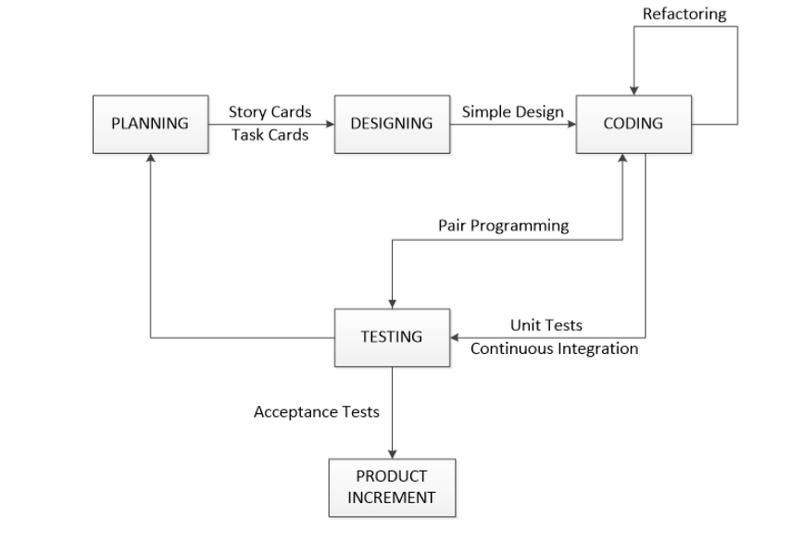

**Extreme Programming**

The four stages of the Extreme Programming Model are Planning, Design, Coding, and Testing. This approach to agile software development seeks to deliver high-quality software while improving the working environment for the development team. The model, which is depicted in Figure 3, demonstrates that the software process follows an incremental and iterative cycle. Brief explanations of the steps and the duties performed in each are covered by the sections that follow.

**Planning Phase**

In the planning phase, the researchers have employed the following fact-finding strategies in order to obtain precise data from the client. The team has spoken with some students and dormitory administrator about the services provided to them and the issues related to the environment in order to gather background information and fundamental facts about the current management system. On-the-job observation: In this instance, the team was responsible for implementing the online reservation for tenants, updating reports and data entry forms related to the management process.

**Software** **Design**

The class diagram serves as the blueprint for CASA ALL'INTERNO LA SCUOLA. In the model-view controller architecture, the classes used in the programs are divided into views, which contain the user interface, controllers, which contain the business logic, and models, which contain classes for data access

**Coding Phase**

In the coding phase, the Use Case Diagram is implemented into actual source code. The Scripting language chosen by the researchers to be used is PHP, web languages such as HTML, CSS, bootstrap for the design of the system, JavaScript for coding the functions of the system and MySQL for the database. As a coding method, pair programming will be done to write the code and run unit tests. In this phase, the programmer and the tester will be working together to develop the system.

**Test Phase**

Testing was done after the system was established to see if there were any adjustments that needed to be made or removed before the project could be put into action. Integration, compatibility, system, and acceptability testing were all done by the researchers.

**Integration** **Testing**

Each feature was added to the system and tested to see how well it worked with existing implemented features.

**Compatibility Testing**

Cross Browser Testing was done in order to see how well it worked with existing implemented features and how application works across different browsers.

**System Testing**

System testing makes sure an application works as intended. This procedure, which functions as a form of black box testing, focuses on an application's functionality. For instance, system testing may examine whether each type of user input results in the desired output throughout the application.

**Requirements Analysis**

**REQUIREMENT SPECIFICATIONS**

Identification of Requirements

The first phase of the project is the requirement specification. We have divided this phase into 3 modules.

The 3 modules in the project are,

• UI Creation and Database Design

• User Module

• Admin Module

UI Creation and database Design:

In the initial phase of the implementation the User Interface has to be designed, which makes user feel comfortable.

It will support the user to check the availability of the beds according to the dates. Once UI design completed, then

main focus is on database design. The database will be designed with all the required tables and the relationships

derived.

User Module:

The second module in the project is to satisfy all the user’s requirements. This module starts with designing a user

account for the respective user. In this module user can register with the System by giving his personal information.

Once the registration is completed the user can login in to the system and can check for the availability of the beds.

Admin Module:

In this module the administrator’s activities are developed. The administrator can add a bed or delete a bed. He has

all the control over the system. The administrator can login with his email address and password. Here the password

is encrypted and stored in the database using some encryption algorithms. While retrieving the password to login the

system decrypts the password using respective decryption algorithms

**Requirements Documentation**

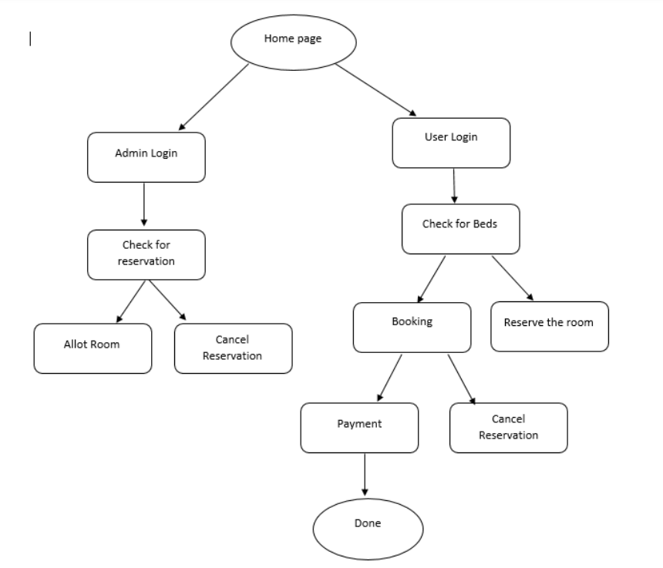

**Design of Systems**

The first step is to identify Actors and use cases associated with the system. The following table specifies the actors and use cases that a group member have identified with in the proposed new system. The table also describes use case descriptions associated with the corresponding use cases.

The second step is to construct the use case model which graphically depicts the interaction of the system with the external environment. The following figure specifies the use case model of the system.

The third step is to document each of the above use case courses of events to determine the requirement use cases as described in the following section.

**Implementation Plan**

The Nueva Vizcaya State University Dormitory will use the CASA ALL'INTERNO LA SCUOLA in Bambang Campus. The implementation and installation of the server will take place at the CAS building, where the university's server room is located, an access point will be needed for the students to access the CASA ALL'INTERNO LA SCUOLA.